
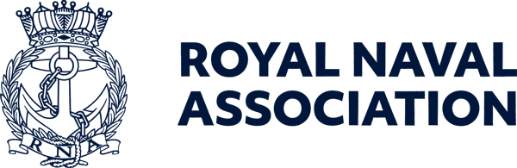

Semaphore Short Friday 31 July 2026

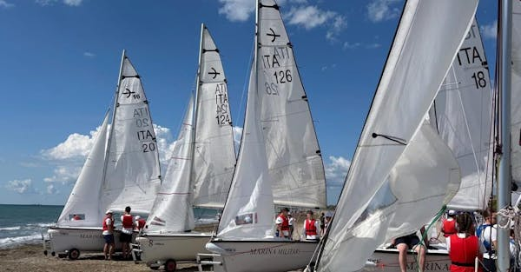

Sailing camp under way

The International Maritime Confederation (IMC) Sailing Camp is well under way – and is proving to be a fantastic experience for young people from across Europe.
Our UK team is having a brilliant time at camp, embracing new challenges, developing their sailing skills and making lasting friendships, all with the breath taking backdrop of Venice.
Opportunities like these are about so much more than sailing. They help young people from the Naval family build confidence, independence and lifelong friendships while experiencing the unique camaraderie that comes from being part of an international community.
Thank you to the Naval Children's Charity for the funding which made this possible.
See our social media channels and next Friday's Semaphore Circular for more details.

  We want your opinion on Conference
  We would still like to hear your views on the 2026 RNA National Conference and Annual General Meeting in Salford last month.
  We are constantly striving to improve the programme for the annual gathering, and organising Branches and Areas welcome the guidance that comes from feedback by delegates, observers and other shipmates who attend Conferences.
  Positive or negative, all comments and suggestions are valuable in giving us an insight into additions (or subtractions!) that could add to the overall experience of shipmates.
  Please fill in our feedback form – use the QR code right or click on this link to a microsoft form.
  

Major work ahead
Lanyard Building, the home of RNA Central Office in Portsmouth Naval Base, is undergoing an overhaul.
An initial electrical survey has been carried out, and it is estimated that work arising from this will last until the end of September.
This will inevitably lead to some diisruption of our normal office routines, but we will do our very best to mitigate against this.
Other inspections will also be made of the building structure, so there could be further work which needs to be carried out – please keep an eye on our social media platforms and communications channels for further details as we get them.

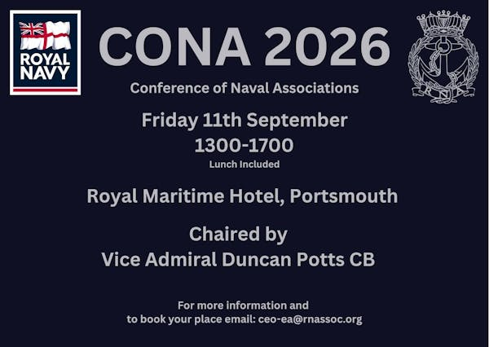

Conference call
We still have a limited number of spaces for delegates to the CONA gathering in Portsmouth in September.
CONA – the Conference of Naval Associations – is a forum for representatives of Naval associations across the UK to network, share ideas, strengthen connections and discuss issues of importance to the wider Naval community.
Whether you are involved with an association, a Branch committee, or simply interested in the organisations that support the wider Naval family, CONA offers an opportunity to meet fellow members, hear from guest speakers and contribute to important discussions.
The meeting will take place at the Royal Maritime Hotel in Queen Street, Portsmouth on Friday 11 September between 1pm and 5pm – to book your place contact Milly on ceo-ea@rnassoc.org
Please note – delegates qualify for a ten per cent discount when booking a room at the Royal Maritime Hotel if they quote CONA.

Fly the flag for the Merchant Navy

The Seafarers' Charity is calling on communities across the UK to celebrate the Merchant Navy by flying the Red Ensign on Merchant Navy Day, 3 September.
Since its inception in 2015, the campaign has grown into a significant national event.
The Red Ensign, known affectionately as the 'Red Duster,' is flown at historic properties, political establishments, civic buildings and village greens across the nation – a powerful symbol serving to highlight the indispensable role of merchant seafarers past, present, and future.
Merchant Navy seafarers’ bravery kept supply lines open during global conflicts including the world wars, as well as during crises such as the Covid-19 pandemic. Today, merchant seafarers are indispensable, handling 95 per cent of the UK’s traded goods, yet continue to face stern challenges such as the ongoing situation in the Strait of Hormuz.
For more details see https://www.theseafarerscharity.org/get-involved/merchant-navy-day

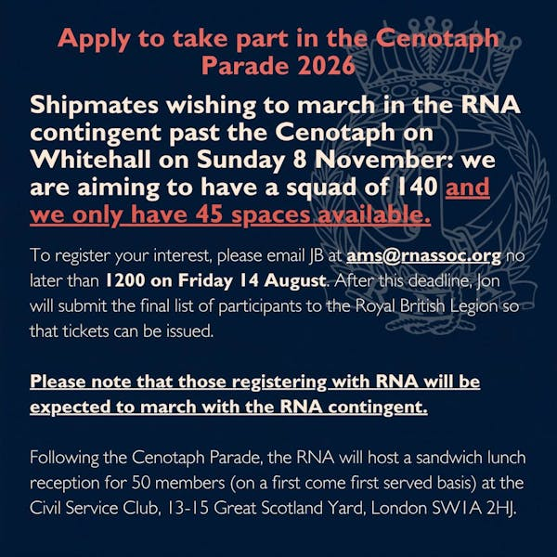

Remembrance registration

Any shipmates interested in marching with the RNA at the November Remembrance Sunday ceremonies in London should register their interest by emailing JB at ams@rnassoc.org no later than 1200 on Friday 14 August.
After this deadline, Jon will submit the final list of participants to the Royal British Legion.
Please note – those registering with the RNA will be expected to march with the RNA contingent.
In order to march you must possess at least one of the following:
• Veterans Recognition (ID) Card
• Veterans UK Status Card
• Certificate of Service – this must include date of discharge
• Certificate of Discharge
• Veterans Railcard
• For Merchant Mariners – a copy of the personal details page of your Discharge Book, along with the vessel names on which you served and the operation names and date.
Please check the RBL Website eligibility details: https://www.britishlegion.org.uk/.../remembrance-sunday
Remembrance Sunday this year is 8 November.

No Salisbury meeting in August

Salisbury Branch will not be holding a meeting in August.
Branch officers wanted other branches to be aware in case any shipmates from other parts of the country were thinking of visiting Salisbury during the month!
Their next meeting will be held on Monday 14 September.

Pitch perfect

The SSAFA Cricket Day at Wormsley, near High Wycombe, offers the rare opportunity to play at one of the most beautiful cricket grounds in the world while supporting a leading military charity.
The event – on Friday 11 September – will feature two T20 fixtures, a barbecue lunch, hospitality, networking opportunities and an event village for company branding and engagement.
Team entries are available for £4,000 or up to 12 players, with additional spectator tickets priced at £50 per person.
Individual places are available for £350, or participants can secure a place for £50 and commit to raising a minimum of £300 for SSAFA.
Whether you are entertaining clients, rewarding colleagues or simply enjoying a day of cricket at this outstanding ground at Stokenchurch, it promises to be a unique experience in support of serving personnel, veterans and their families.
To register your interest or book your place, please contact events@ssafa.org.uk



Luxury holiday up for grabs

This summer, Royal Navy & Royal Marines Charity is one of the beneficiary charities of the RaiseHero 50/50 Raffle.
Enter from just £5 for your chance to win incredible prizes – including a holiday for two in the Maldives – while helping to support those who serve in the Royal Navy, Royal Marines and Royal Fleet Auxiliary.
The main draw takes place on 30 September, with the prize being a luxury Maldives holiday for two, with white-sand beaches, crystal-clear waters and £10,000 cash to spend. Or you could take home a £20,000 cash alternative.
And if you spend £25 or more and you’ll be entered into a bonus draw to win £1,000 cash.
There are also weekly bonus prizes, so the earlier you enter, the more bonus draws you'll be eligible for:
- Dyson Hot & Cool fan – 5 August
- Ninja Woodfire grill – 12 August
- Ninja Double Stack air fryer – 19 August
- iPad – 26 August
- Apple smartwatch – 2 September
- Fortnum & Mason hamper – 9 September
- Ninja coffee machine – 15 September
- Nintendo Switch – 22 September
Every entry supports the Royal Navy & Royal Marines Charity, with 50 per cent of tickets purchased helping those who serve, have served, and their families.
For full details of the raffle and rules see https://rnrmc.the5050raffle.com

 |  |  |  |  |  |  |  |  |  |  | 

